**Assignment #03**

Q.1 Write a Dart program to check if a given number is positive, negative, or zero.

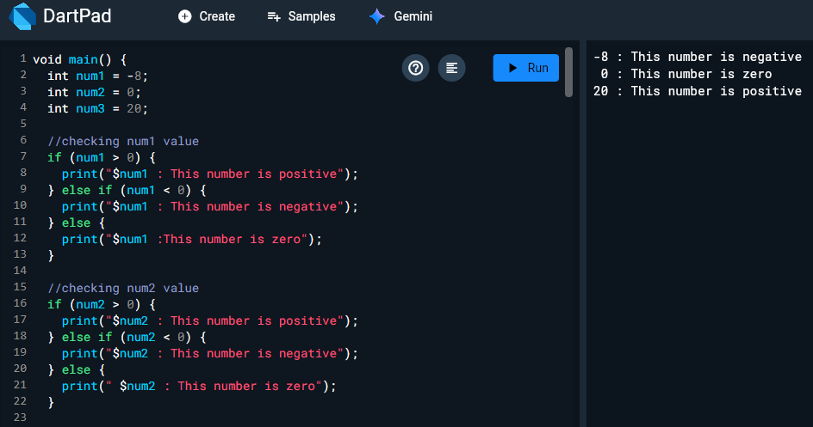

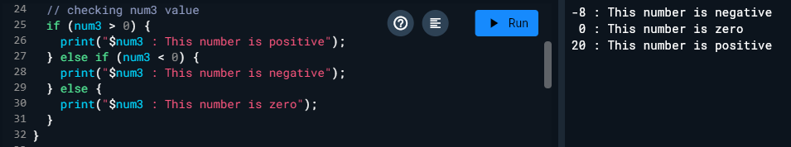

Q.2: Write a Dart program to check if a given number is even or odd.

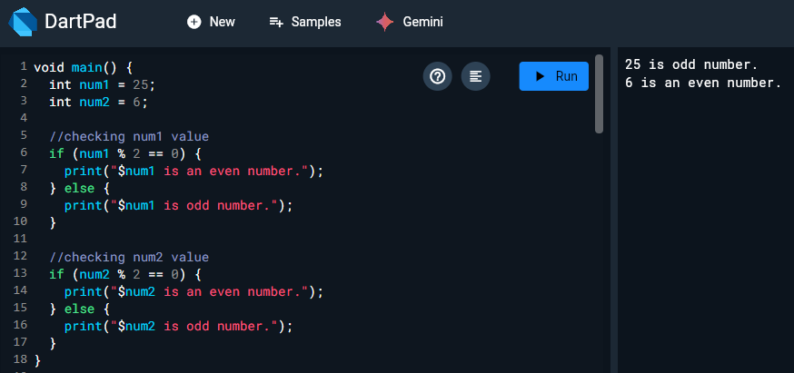

Q.3 Write a Dart program to determine if a given year is a leap year or not, considering leap years occur every 4 years except for years divisible by 100 unless they are also divisible by 400.

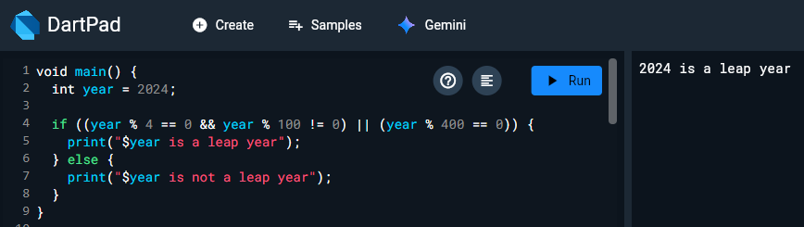

Q.4: Develop a Dart program to find the largest of three numbers.

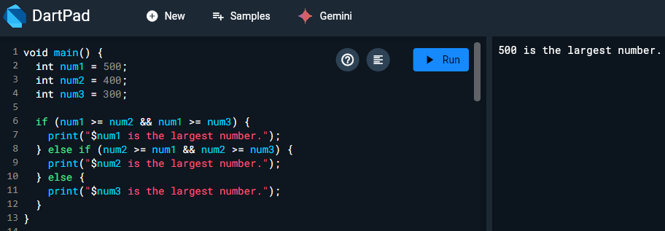

Q.5: Write a Dart program to check if a given year is a century year (ends with 00).

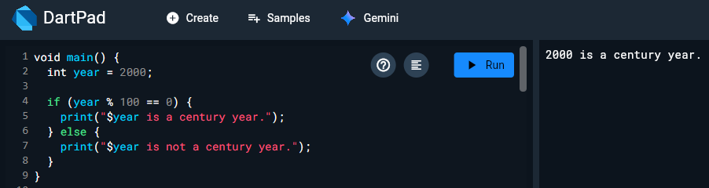

Q.6: Write a Dart program to check if a given number is divisible by 5 and 11.

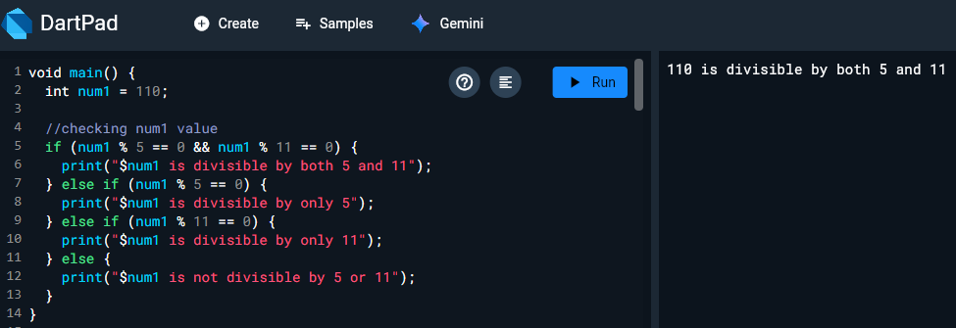

Q.7: Write a Dart program to check if a given number is a multiple of 3 or 7.

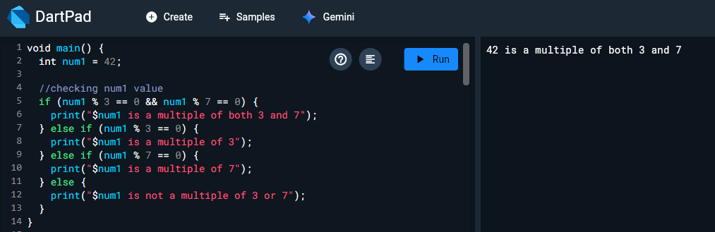

Q.8: Make a marksheet , calculate percentage and complete.

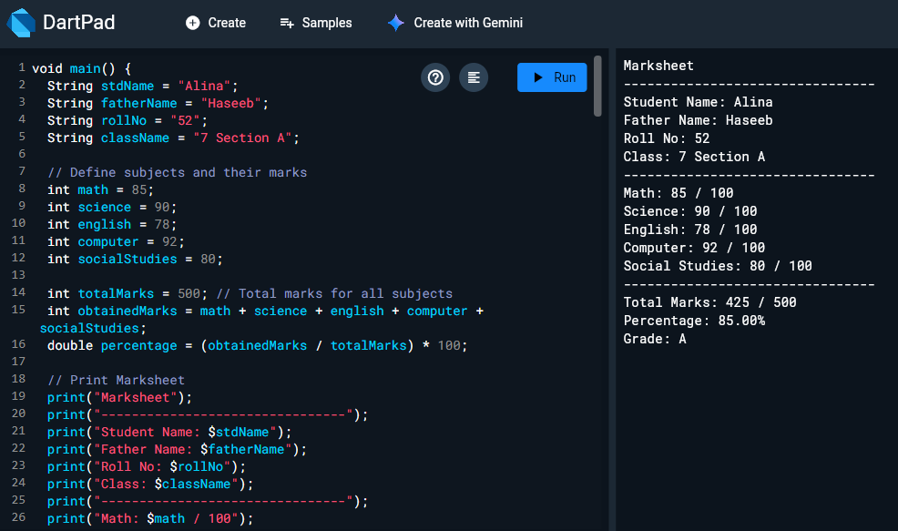

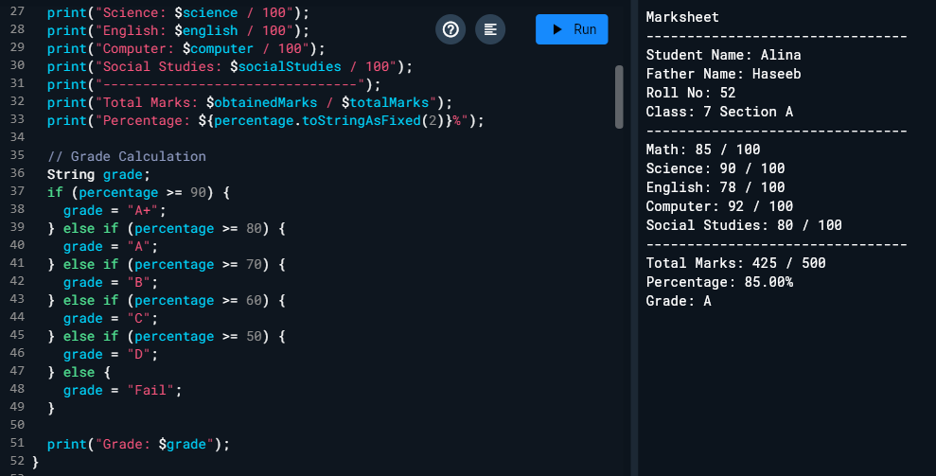

Q.9: Write a program create two integer variables 'a' and 'b' and assign them any number and then check if both the conditions 'a < 50' and 'a < b' are true. Display the result, now check if at-least one of the conditions 'a < 50' and 'a < b' is true.

